# Accessibility Camp CdA Schedule

This year, A11y Camp will have sessions in two locations on the second floor of the Edminster Student Union Building. The Lake Coeur d’Alene Room will host the main sessions and Blue Creek will provide breakout sessions.

The schedule is comprised of three tracks to ensure that every level of expertise can glean knowledge from this event:

**Passion Icon** **Passion Session** – Great for ALL!

 **Specialized Session** – Deep dive into a specific area or topic of accessibility.

**Technical Icon** **Technical Session** – Sessions that take a “how to” approach for a specific accessible outcome.

## Tuesday, July 29, 2025

**7:30 AM** - Check-in Table Open.

**8 to 9 AM** – Breakfast pastries and coffee/tea in the Silver Beach Gallery on the 2nd floor of the Edminster Student Union Building.

**9 AM to 3 PM** – Coffee/tea in the Blue Creek/Echo Bay room on the 2nd floor of the Edminster Student Union Building.

| Time | Lake Coeur d’Alene Room |
| --- | --- |
| 9 AM to 12 PM | **Specialized Icon Document Accessibility for the Absolute Beginner (Part 1)** – *Dax Castro & Chad Chelius* (Session Description: T-0900) |
| 12-1 PM | Lunch Provided by NIC |
| 1-4 PM | Specialized Icon **Document Accessibility for the Absolute Beginner** (Part 2) – *Dax Castro & Chad Chelius* |

## Wednesday, July 30, 2025

**7:30AM** - Check-in Table Open.

**8 to 9 AM** – Breakfast pastries and coffee/tea in the Silver Beach Gallery on the 2nd floor of the Edminster Student Union Building.

**9 AM to 4 PM** – Coffee/tea in the Blue Creek/Echo Bay room on the 2nd floor of the Edminster Student Union Building.

| Time | Lake Coeur d’Alene Room | Blue Creek Room |
| --- | --- | --- |
| 8:30 to 8:55 AM | Welcome to A11y Camp CdA, Opening Prayer, & Housekeeping Items – *Jeremy Seda*  (Session Description: W-0830) | (see Lake Coeur d’Alene Room) |
| 8:55 to 9:00 AM | [5 minute tech break] | [5 minute tech break] |
| 9:00 to 9:45 AM | Technical Session **Vibe Coding AIMAC, the AI Model Accessibility Checker. An AI Benchmark for Accessibility** – *Joe Devon*  (Session Description: W-0900-T) | (see Lake Coeur d’Alene Room) |
| 9:45 to 10:00 AM | [15 minute break] | [15 minute break] |
| 10:00 to 10:45 AM | **Specialized Session** **Artificial Intelligence and Assistive Technology** – *Myles Pilling*  (Session Description: W-1000-S) | Technical Session **Accessible PDFs from Microsoft Word** – *Chad Chelius* (Session Description: W-1000-T) |
| 10:45 AM to 11:00 AM | [15 minute break] | [15 minute break] |
| 11:00 to 11:45 AM | Technical Session **YuJa Panorama Overview** – *Michael Cosgrave*  (Session Description: W-1100-T) | (see Lake Coeur d’Alene Room) |
| 11:45-1:00 PM | Lunch Provided by NIC | (see Lake Coeur d’Alene Room) |
| 1:00-1:45 PM | **Specialized Session** **Digital Accessibility Long Overdue: Countdown to Compliance** – *Angelina Smith* (Session Description: W-1300-S) | (see Lake Coeur d’Alene Room) |
| 1:45-2:00 PM | [15 minute break] | [15 minute break] |
| 2:00-2:45 PM | **Specialized Session** AI as an Ally: Empowering Disability Services and Their Students– *Erin C. Lucas* (Session Description: W-1400-S) | **Specialized Session Round Table Discussion: Strategy & Tactics to Prepare for Title II Update to the ADA**– *Moderated by Amy Taylor*(Session Description: W-1400-S2) |
| 2:45-3:00 PM | [15 minute break] | [15 minute break] |
| 3:00-3:45 PM | Technical Session **Accessibility Workflows for Success** *– Dax Castro & Chad Chelius* (Session Description: W-1500-T) | **Specialized Session Idaho Commission for the Blind and Visually Impaired** – *Jackie Stallings* (Session Description: W-1500-S) |
| 3:45-4:00 PM | [15 minute break] | [15 minute break] |
| 4:00-5:00 PM | **Passion Session Standup Comedy Show –** *D.J. Demers* (Session Description: W-1600-P)  Add to [Outlook](https://www.nic.edu/media/nic-main/departments/accessibility/a11ycamp/2023/sessions/W-1600-P.ics) or [Google](https://www.google.com/calendar/render?action=TEMPLATE&text=W-1600-P%3A+Comedy+Show+-+Hayden+Kristal&details=Comedian+Hayden+Kristal+delivering+HILARIOUS+Stand-Up+Comedy+routine+to+close+out+Day+1+of+A11y+Camp+CdA+2023.&location=Lake+Coeur+d%27Alene+Room&dates=20230802T230000Z%2F20230803T000000Z) | (see Lake Coeur d’Alene Room) |
| 5:00-5:10PM | Day 1 Closing Remarks – *Jeremy Seda* | (see Lake Coeur d’Alene Room) |

6:00PM ISU After Hours Networking Event—Dinner & “No Host” bar:  
**Wrist-band (distributed during closing remarks) or conference badge required.**  
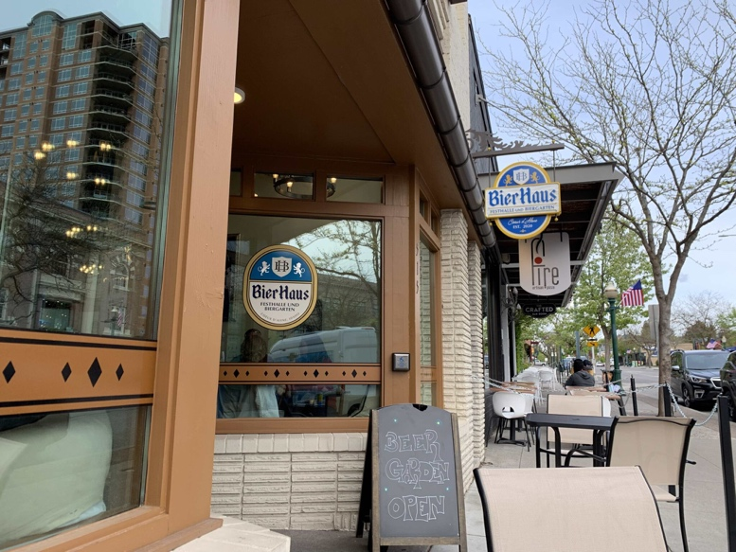[**Bier Haus**](https://www.bierhauscda.com/)(https://www.bierhauscda.com/)  
515 E Sherman Ave  
Coeur d'Alene, ID 83814  
[Menu](https://www.bierhauscda.com/menu/)  
(bierhauscda.com/menu/)  
Phone: 208-966-4301  
Email: [prost@bierhauscda.com](mailto:prost@bierhauscda.com)

## Thursday, July 31, 2025

**8 to 9AM** – Breakfast pastries and coffee/tea in the Silver Beach Gallery on the 2nd floor of the Edminster Student Union Building.

**9 AM to 4 PM** – Coffee/tea in the Blue Creek/Echo Bay room on the 2nd floor of the Edminster Student Union Building.

| Time | Lake Coeur d’Alene Room | Blue Creek Room |
| --- | --- | --- |
| 9:00 to 9:45 AM | Technical Session **Math Content: Accessibility Tools & Alternative Formats** – *Natalie Davison*(Session Description: TH-0900-T) | **Specialized Session** **Artificial Intelligence - Friend or Foe** – *Myles Pilling* (Session Description: TH-0900-S) |
| 9:45 to 10:00 AM | [15 minute break] | [15 minute break] |
| 10:00 to 10:45 AM | Passion Session **Building Empathy with Dark Patterns** – *Chris Gaulin*(Session Description: TH-1000-P) | Technical Session **Diving Deeper into YuJa Panorama** – *Michael Cosgrave*  (Session Description: TH-1000-T) |
| 10:45 to 11:00 AM | [15 minute break] | [15 minute break] |
| 11:00 to 11:45 AM | Specialized Session **Evolution of the Low-Vision Classroom: Improving Access & Inclusion**– *Jeff Gardner*  (Session Description: TH-1100-S) | Technical Session **Beyond Automation: The Basics and Benefits of Manual Accessibility Testing** – *Angelina Smith*  (Session Description: TH-1100-T) |
| 11:45 AM to 1:00 PM | Lunch Provided by NIC | (see Lake Coeur d’Alene Room) |
| 1:00 to 1:45 PM | Specialized Session **Digitalization, AI & Inclusion in Higher Education: EDF’s Perspective** – *Dr. Humberto Insolera* (Session Description TH-1300-S) | Technical Session **Creating Accessible PPT Documents**– *Dax Castro* (Session Description: TH-1300-T) |
| 1:45 to 2:00 PM | [15 minute break] | [15 minute break] |
| 2:00 to 2:45 PM | **Specialized Session Inaccessible Accessibility** – *Christa Peters* (Session Description: TH-1400-S) | Technical Session **Accessibility using Venngage** – Chad Chelius (Session Description: TH-1400-T) |
| 2:45 to 3:00 PM | [15 minute break] | [15 minute break] |
| 3:00 to 3:45 PM | **Specialized Session** **KEYNOTE: Beyond Compliance: Crafting Audio Description That Audiences Feel** –*Roy Samuelson* (Session Description: TH-1500-S) | (see Lake Coeur d’Alene Room) |
| 3:45 to 4:00 PM | [15 minute break] | [15 minute break] |
| 4:00 to 4:45 PM | Passion Session **Accessibility Salsa** *– Jeff Gardner, Karina Mason-Rorris, & Jeremy Seda* (Session Description: TH-1600-P) | (see Lake Coeur d’Alene Room) |
| 4:45 to 5:00 PM | Day 2 Closing Remarks – *Jeremy Seda* | (see Lake Coeur d’Alene Room) |

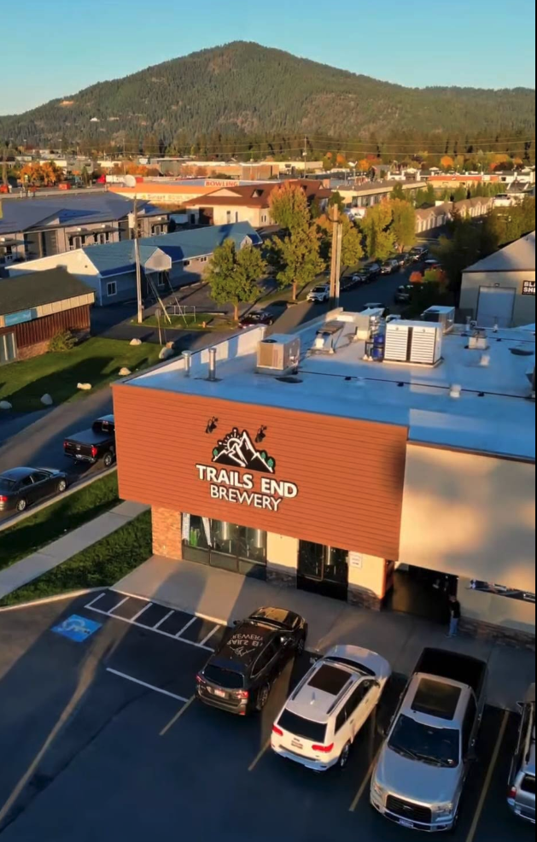6:00 PM [Irie-AT](https://irie-at.com/) After Hours Networking Event—Dinner & “No Host” bar:

**Wrist-band (distributed during closing remarks) or conference badge required.**

[**Trails End Brewery & Brick-oven Pizza**](https://www.trailsendbrewery.com/)   
(URL: www.trailsendbrewery.com)  
356 W Bosanko Ave  
Coeur d'Alene, ID 83815  
[Menu](https://www.trailsendbrewery.com/food-menu/)  
(URL: www.trailsendbrewery.com/food-menu)  
Phone: 208-292-4013  
Email: info@TrailsEndBrewPub.com