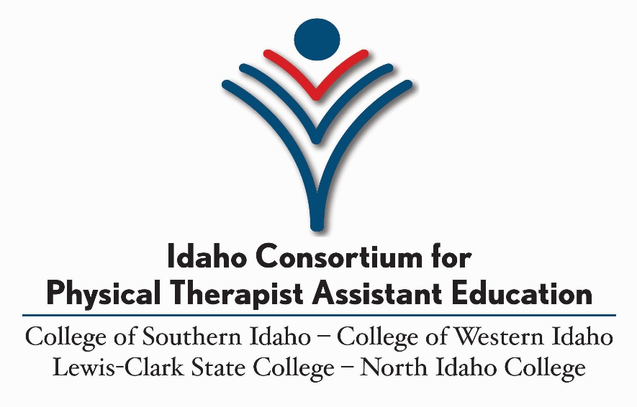

# ASSOCIATE OF APPLIED SCIENCE PHYSICAL THERAPIST ASSISTANT

# APPLICATION PACKET FOR PROGRAM ENTRY

# FALL SEMESTER 2025

The application period is March 24, 2025 – May 22, 2025.  
All materials must be received **no later than Thursday, May 22, 2025.**

Welcome to the Idaho Consortium for Physical Therapist Assistant Education (ICPTAE) admissions process. Please read these documents thoroughly as they will help you understand the requirements for admission and guide you through the admissions process. Do not hesitate to contact the program director, your health programs advisor, or other physical therapist assistant program faculty with concerns or questions during the process. Contact information is below.

The Idaho Consortium for Physical Therapist Assistant Education abides by each member college’s practice of non-discrimination and therefore will not discriminate against any individual on the basis of race, color, religion, national origin, gender, age, disability, pregnancy, sexual orientation, or status as a Vietnam-era veteran.

Space in the program is limited; therefore, admission will be competitive, based on an objective point procedure that has been strategically set up to predict student success.

The program will admit students as follows in Fall 2025:

* 14 students at the College of Western Idaho (CWI) in Nampa,
* 10 students at the College of Southern Idaho (CSI) in Twin Falls,
* 6 students at the Lewis-Clark State College (LCSC) in Lewiston, and
* 10 students at North Idaho College (NIC) in Coeur d’Alene.

Students are accepted into a “cohort,” a group of students who start the program at the same time, enroll, and complete the same program courses, perform clinical education, and graduate together as a group. The program may not be taken part-time – it is a full-time commitment.

Prior to making application to the program, individuals should give careful consideration to the mental and physical demands of the program and the pressures involved in undertaking the responsibilities of being a full-time PTA student.

It is highly recommended that you meet with an advisor early in the application process. Direct questions and prerequisite course verification to:

* Jon Gardunia (NIC) ICPTAE Program Director [jon.gardunia@nic.edu](mailto:jon.gardunia@nic.edu) (208) 665-5051
* Betsy Conery (NIC) Health Professions Advisor [betsy.conery@nic.edu](mailto:betsy.conery@nic.edu) (208) 625-2320
* Denali Minnick (CWI) Student Advising & Success [denaliminnick@cwi.edu](mailto:denaliminnick@cwi.edu) (208) 562-3162
* Jacob Hornby (LCSC) Pre-Health Prof Advisor[jmhornby@lcsc.edu](mailto:jmhornby@lcsc.edu)(208) 792-2441
* JoAnn Schroedter (CSI) Health Science Advisor [jschroedter@csi.edu](mailto:jschroedter@csi.edu) (208) 732-6730

## Accreditation Status

The Idaho Consortium for Physical Therapist Assistant Education at the College of Southern Idaho, the College of Western Idaho, Lewis-Clark State College, and North Idaho College **is accredited by the Commission on Accreditation in Physical Therapy Education (CAPTE)**, 1111 North Fairfax Street, Alexandria, Virginia 22314; telephone: 703-706-3245; email: [accreditation@apta.org](mailto:accreditation@apta.org); website: [http://www.capteonline.org](http://www.capteonline.org/). To contact the program/institution, please reach out directly by calling (208) 665-5051 or emailing [jon.gardunia@nic.edu](mailto:jon.gardunia@nic.edu).

-Keep this page-

## Application Checklist

All materials must be received no later than Thursday, May 22, 2025.

Admission Application to Your College ** Complete  Incomplete**

Not necessary if you are a current student, but you will need to apply to each college you are applying for on each respective college website.

Application to the ICPTAE Program ** Complete  Incomplete**

This program application must be complete. For CWI and CSI, applicants are required to complete this application document and submit it along with all other required items as noted. For NIC and LCSC, applicants are required to submit an electronic application by accessing <https://www.nic.edu/start/> online and clicking on the ‘Get Started’ and ‘Apply Now’ links to complete a degree-seeking application for the Fall 2025 Physical Therapist Assistant (PTA) Program. Additionally, NIC and LCSC applicants must submit all other required items as noted. IMPORTANT NOTE: The PTA Program has prerequisites required for entry. Information about the program and all required prerequisite courses can be found on the PTA Program <https://www.nic.edu/pta/> website. Prerequisite courses are also listed on page 16 of this application packet.

Physical Therapist Assistant Reference Form ** Complete  Incomplete**

Submit 2 completed reference forms **(See page 5-7 & 8-10)**. The applicant must complete the first page and then provide all three pages to the person completing the reference detail. The applicant should also provide an addressed, stamped envelope to the person so the completed reference form pages (all three pages) can be easily mailed/sent to the selected college prior to the application deadline. The address used should be the consortium school which is your first choice (see page 13). Copies will be forwarded to other campuses as needed.

College Transcripts ** Complete  Incomplete**

NOTE: The following applies only to students who are transferring credits in from another college. If you have taken courses only at the campus to which you are applying, IGNORE THIS STEP.

***CSI:*** Official high school, college, and military transcripts must be on file with the Office of the Registrar *prior* to submitting your ICPTAE application. It is your responsibility to confirm that your official transcripts are complete, up–to-date, and available for evaluation purposes *prior to* submitting your application. Check MyCSI to verify receipt of previous transcripts and HSHS department to verify receipt of application materials prior to the deadline. **(See page 2 for cohort offering information).**

***CWI*:** Official college and military transcripts must be received by the One-Stop Office *prior* *to* submitting your ICPTAE application. It is your responsibility to confirm that your official transcripts are complete, up–to-date, and available for evaluation purposes *prior to* submitting your application. **If you hold an advanced degree, you must complete a Bachelor Equivalency Form and submit to One-Stop Office.**

-Keep this page-

***NIC/LCSC:*** Official college and military transcripts are to be submitted afteryou apply to the program ***but no later than the application deadline***. It is your responsibility to confirm that your official transcripts are complete, up-to-date, and available for evaluation purposes immediately *after* submitting your ICPTAE application. To verify receipt and acceptance of application materials by the college, log into your **MyNIC** account after you have applied to the program. Select **Self Service** under the **Services** area. Once in **Self Service**, refer to the left-hand side panel, select the person avatar icon (**User Options**) and select **My Documents**. If the status column indicates an item is missing, that document may be required for your program application file. All required application items must be received by the application deadline. If a required item is listed as missing at the application deadline, your application may not be considered for review.

Physical Therapy Clinical Observation/Work ** Complete  Incomplete**

Documentation showing that you have completed a minimum of 16 hours of observation in a physical therapy clinical setting. All hours must be under supervision of a physical therapist and/or PTA. You must include proof of hours from each clinical site if observation occurred at more than one setting. Documentation should be as follows:

* on the facility's formal letterhead,
* must have the number of hours recorded, and
* must be signed/dated by the supervising physical therapist or PTA.

Individuals who currently work or previously worked in a physical therapy setting may submit a letter with the same criteria.

Asynchronous Interview ** Complete  Incomplete**

After the application deadline, eligible applicants will be emailed a Flipgrid link and access code. Applicants will have 3 days to record a 2-minute response to 4 interview questions and to ask the program any relevant questions.

*-Keep this page-*

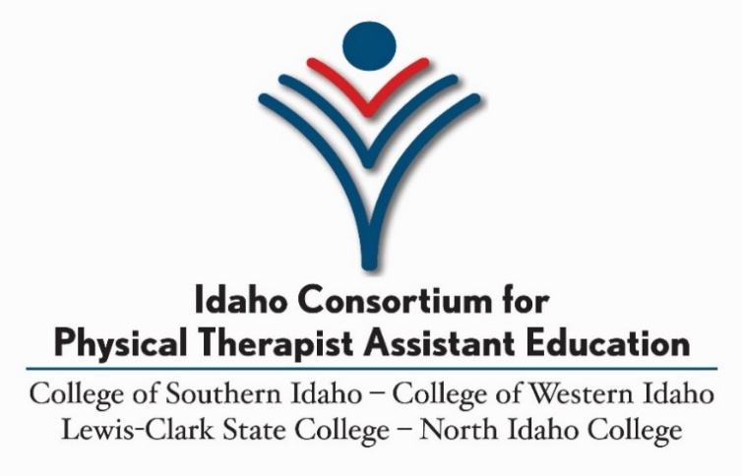

## Reference Form for Fall 2025

The ICPTAE Program Application requires two references. This Reference Form can be completed by any of the following persons: PT, PTA, Healthcare Provider, Professor, Instructor, Advisor or Employer. There may NOT be any familial relation between the student and person providing the reference.

## Student/Applicant Information

Last Name First Name M.I.

Address City State Zip Code

I, __________________________ (print full name), understand that by signing below I agree to waive my right to access and examine this form, now or at any time in the future.

**Applicant Signature Date**

**Applicant Instructions:** Provide the person filling out this form with an addressed, stamped envelope. Address used should be the consortium school which is your first location choice (see page 13). Copies will be forwarded to other campuses as needed.

**Reference Instructions:** The information provided on this form is completely confidential. At no time will the contents of this form be shared with the applicant. Please answer the questions to the best of your ability and return in the envelope provided. Be aware that you may be contacted if further information is needed.

Please indicate your level of knowledge of the applicant:

|  |  |  |  |
| --- | --- | --- | --- |
|  | Thorough | General | Minimal |
|  | Knowledge | Knowledge | Knowledge |
| Training |  |  |  |
| Work Experience |  |  |  |
| Abilities |  |  |  |

Please elaborate on above checked box(es):

How long have you known the applicant?

Do you believe, on the basis of ethical conduct, personal character, emotional maturity, and judgment, the applicant will be a credit to the profession of Physical Therapy?

[ ] Yes [ ] No

Please explain

Do you have any reservations about fully recommending this applicant for the ICPTAE Program?

[ ] Yes [ ] No

Please explain

Please rate the applicant’s traits based on your level of knowledge:

|  |  |  |  |  |  |
| --- | --- | --- | --- | --- | --- |
| **CHARACTERISTIC** | **SUPERIOR** | **ABOVE AVERAGE** | **NEUTRAL** | **AVERAGE** | **BELOW AVERAGE** |
| Attention to Detail |  |  |  |  |  |
| Attitude |  |  |  |  |  |
| Relationships with others/peers/subordinates |  |  |  |  |  |
| Team-work |  |  |  |  |  |
| Personal integrity and honesty |  |  |  |  |  |
| Reliability |  |  |  |  |  |
| Overall performance in past role(s) with your organization |  |  |  |  |  |
| Calmness under pressure |  |  |  |  |  |
| Competence |  |  |  |  |  |
| Ambition |  |  |  |  |  |

Additional Comments

*Please feel free to attach a written letter of recommendation to this document.*

________________________________________ Signature of person completing reference form

________________________________________

Printed Name & Professional Credentials

________________________

Date

*-Have your reference submit this 3-page completed form directly to college before the application deadline-*

*Complete the first page of the form before providing all 3 pages w/stamped, addressed envelope to the reference.*



## Reference Form for Fall 2025

The ICPTAE Program Application requires two references. This Reference Form can be completed by any of the following persons: PT, PTA, Healthcare Provider, Professor, Instructor, Advisor or Employer. There may NOT be any familial relation between the student and person providing the reference.

## Student/Applicant Information

Last Name First Name M.I.

Address City State Zip Code

I, __________________________ (print full name), understand that by signing below I agree to waive my right to access and examine this form, now or at any time in the future.

**Applicant Signature Date**

**Applicant Instructions:** Provide the person filling out this form with an addressed, stamped envelope. Address used should be the consortium school which is your first location choice (see page 13). Copies will be forwarded to other campuses as needed.

**Reference Instructions:** The information provided on this form is completely confidential. At no time will the contents of this form be shared with the applicant. Please answer the questions to the best of your ability and return in the envelope provided. Be aware that you may be contacted if further information is needed.

Please indicate your level of knowledge of the applicant:

|  |  |  |  |
| --- | --- | --- | --- |
|  | Thorough | General | Minimal |
|  | Knowledge | Knowledge | Knowledge |
| Training |  |  |  |
| Work Experience |  |  |  |
| Abilities |  |  |  |

Please elaborate on above checked box(es):

How long have you known the applicant?

Do you believe, on the basis of ethical conduct, personal character, emotional maturity, and judgment, the applicant will be a credit to the profession of Physical Therapy?

[ ] Yes [ ] No

Please explain

Do you have any reservations about fully recommending this applicant for the ICPTAE Program?

[ ] Yes [ ] No

Please explain

Please rate the applicant’s traits based on your level of knowledge:

|  |  |  |  |  |  |
| --- | --- | --- | --- | --- | --- |
| **CHARACTERISTIC** | **SUPERIOR** | **ABOVE AVERAGE** | **NEUTRAL** | **AVERAGE** | **BELOW AVERAGE** |
| Attention to Detail |  |  |  |  |  |
| Attitude |  |  |  |  |  |
| Relationships with others/peers/subordinates |  |  |  |  |  |
| Team-work |  |  |  |  |  |
| Personal integrity and honesty |  |  |  |  |  |
| Reliability |  |  |  |  |  |
| Overall performance in past role(s) with your organization |  |  |  |  |  |
| Calmness under pressure |  |  |  |  |  |
| Competence |  |  |  |  |  |
| Ambition |  |  |  |  |  |

Additional Comments

*Please feel free to attach a written letter of recommendation to this document.*

________________________________________ Signature of person completing reference form

________________________________________

Printed Name & Professional Credentials

________________________

Date

*-Have your reference submit this 3-page completed form directly to college before the application deadline-*

*Complete the first page of the form before providing all 3 pages w/stamped, addressed envelope to the reference.*

## Transcripts

Transcripts are required only if you have taken courses and are transferring credits from a college OTHER than the one to which you are applying.

Arrange for your **official** transcripts to be sent to your applicable college in order to be evaluated and reflected in your records. *It is not necessary to enclose a copy of transcripts with your ICPTAE application.*

***Example*:** If you have taken all your required general education/prerequisite courses at NIC *and* you are applying to attend the program at NIC, no transcripts are necessary.

If you took all but two of your general education/prerequisite courses at NIC, took one required course at CSI and one required course at CWI, you must have your CSI and CWI official transcripts sent to NIC for evaluation.

**Please Note:** It is highly recommended that students with transfer credits view their transcript evaluations before the application deadline to assure that they have courses that meet the prerequisite admission requirements for the Associate of Applied Science Degree, Physical Therapist Assistant Program.

It is possible that transcripts received during the application period may not be evaluated until after the application deadline, therefore, **it is** **essential that you follow the college's requirements for evaluation of transcripts and do so in a timely manner**. To verify receipt of application materials, check with OneStop at CWI, your MyNIC portal (Self Service) at NIC/LCSC, and with the Office of the Registrar or HSHS advisor JoAnn Schroedter via email to: [*jschroedter@csi.edu*](mailto:jschroedter@csi.edu) at CSI.

-Keep this page-

## IMPORTANT - ADDITIONAL APPLICATION INFORMATION

It is the student’s responsibility to ensure that all required information is submitted and that documentation of all requirements is included in the application.

* Repeated courses: courses may be repeated *once* to improve a grade, no matter when the course was first taken. The *latest*, *most recent* grade will be used in the program admissions scoring process. If a course has been taken more than two times, no application points will be awarded for that course.
* Application points will only be given for courses that have been completed prior to the application period, have a grade of C/2.0 or higher, and are included on official transcripts. In-progress coursework will not be awarded points toward program admission.
* If you are accepted, please be aware that the program is intense and will require the majority of your time and efforts. *Attendance* and *Participation* at each scheduled lecture and lab is mandatory. From the start of the program, you will be expected to conduct yourself in a manner that is required for all health care providers. Merely showing up will not suffice – you must be invested in the program and in your studies. Please do not apply if you know that you do not have the enthusiasm, drive, and desire to immerse yourself in the program and in the profession. If you have questions in this regard, please speak with the program director or your advisor.

**All application materials must be received by Thursday, May 22, 2025.**

**Any materials received after the deadline will not be considered.**

*-Keep this page-*

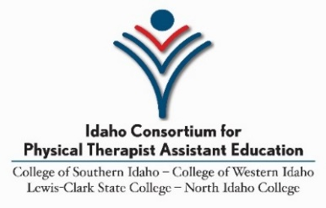

## Application for Admission Fall 2025

* Place a check on the line of the consortium-member college to which you are applying *and* submit materials to the address listed below. The application period is *March 24, 2025 – May 22, 2025*. All application materials must be received by ***May 22, 2025****.*
* Remember, if you have not applied to the college itself, you must apply to the college as well as the ICPTAE Program. NIC/LCSC applicants complete this step through the online program application process.
* If you are applying to multiple locations, you must submit application materials to each location and rate which college is your first choice, second choice, and so on. Except for letters of reference which only need to be sent to the first choice. They will be forwarded to the other campuses as needed.
* If it isn’t already a requirement of your college, we recommend submitting all your ICPTAE application documentation together in one envelope clearly marked, “ICPTAE Application.” Please do not use staples.
* No additional materials will be accepted toward your application after the due date.
* Make and keep a copy of all application materials that you turn in.

If you are applying to multiple colleges: place a 1 for first choice, a 2 for second choice, etc., on the line next to the college name below. If more than one college is selected, an admissions application to each college must be submitted to that institution. **Note:** If you apply to more than one college and you are selected to attend one of the colleges you’ve indicated, **you cannot change to another college campus once you’ve agreed to attend the campus of your acceptance.** If you are applying to one college only, place a **√** on the line for that college:

**_____ College of Western Idaho (Canyon County Campus - Nampa, ID)**

Attention: One Stop

PO Box 3010, MS 3000

Nampa, ID 83653

**_____ North Idaho College (Coeur d’Alene, ID Campus)**

Apply online, then email all program application materials to: [HPN@nic.edu](mailto:HPN@nic.edu)

Application materials can be also be mailed or delivered to:

North Idaho College

Cardinal Central Office (Lee-Kildow Hall)

1000 West Garden Avenue

Coeur d’Alene, ID 83814

**_____ Lewis-Clark State College** **(Lewiston, ID Campus)**

Apply online using the NIC application process and [HPN@nic.edu](mailto:HPN@nic.edu) email noted above.

*Please note: LCSC ICPTAE applicants submit materials to the North Idaho College (NIC) location/address and must apply for admissions to NIC*.

**_____ College of Southern Idaho** **(Twin Falls, ID Campus)**

Health Sciences and Human Services Department

PO Box 1238

Twin Falls, ID 83303-1238

***All applicants must submit this page to indicate program location selection(s). Keep a copy for your records.***



## Fall 2025 Application for Program Admission

**Student Identification Number**

**Name**

Last First Middle Preferred Name

**Other Names Appearing on Records**

**Current Mailing Address**

Street Address City County State Zip

**Home Phone**   **Cell Phone**

**Preferred E-Mail**

Please list **all** colleges attended:

|  |  |  |  |  |
| --- | --- | --- | --- | --- |
| **Name of College, Trade School** | **City & State** | **Dates Attended** | **Grad. Date** | **Degree Earned** |
|  |  |  |  |  |
|  |  |  |  |  |
|  |  |  |  |  |
|  |  |  |  |  |
|  |  |  |  |  |
|  |  |  |  |  |
|  |  |  |  |  |

***CWI/CSI applicants must submit pages 14-15 (in addition to page 13).***

***NIC/LCSC applicants complete pages 14-15 information as part of the online application process.***

**Please read and sign**:

• I hereby certify that the information contained in this application is true and complete to the best of my knowledge.

• I understand that any misrepresentation or falsification of information is cause for denial of admission or expulsion from college.

• I understand that if I am accepted into the ICPTAE Program, my admission will be *conditional*, dependent upon successful completion of a background check. I also understand that the results of this background check may prevent me from admission to the program.

• I understand that I will also have requirements to meet prior to participating in the program's clinical education components. These include, but are not limited to: CPR certification, TB testing, vaccination documentation, and other blood tests.

• I understand that if accepted at a consortium college campus, I must attend all courses and labs at

Applicant’s Signature _________________________________ Date ______________________________

*The Idaho Consortium for Physical Therapist Assistant Education abides by each member college’s practice of non-discrimination and therefore will not discriminate against any individual on the basis of race, color, religion, national origin, gender, age, disability, pregnancy, sexual orientation, or status as a Vietnam-era veteran.*

***CWI/CSI applicants must also submit pages 14-15.***

***NIC/LCSC applicants complete this information as part of the online application process.***

## Application Score Sheet

Grades earned in courses appearing on the official transcript at the application deadline and that meet the requirements for the Associate of Applied Science Degree in Physical Therapist Assistant will be evaluated for points according to the point scale listed below.

Total Possible Points:  **62**

* ***Prerequisite Courses*** must be completed and recorded prior to the application deadline.
* Other completed ***General Education*** courses are listed below and awarded points based on recorded, official grades. These are not required for *admission* but will increase the overall application score.
* Courses that are not completed and therefore not recorded on transcripts receive no points.

|  |  |  |  |
| --- | --- | --- | --- |
| Prerequisite Courses | Grade | Point Scale | Points Earned |
| Anatomy & Physiology 1 (BIOL 227/BIOL 227 Lab) **\*** |  | A = 8 B = 6 C = 4 |  |
| Medical Terminology (CAOT 179 @ NIC, ALLH 101 @ CSI, HLTH 101 @ CWI, MEDPT 173 @ LCSC) |  | A = 5 B = 4 C = 3 |  |
| English Composition (ENGL 101 @ All Schools) ** |  | A = 4 B = 3 C = 2 |  |
| Required General Education (GEM 3) Math  (MATH 123, 130, 143, 147, 153, 160, 170, 253) |  | A = 4 B = 3 C = 2 |  |
|  |  |  |  |
| General Education Courses | Grade | Point Scale | Points Earned |
| Anatomy & Physiology 2 (BIOL 228/BIOL 228 Lab) * |  | A = 8 B = 6  C = 4 |  |
| Communication (COMM 101 @ All Schools) |  | A = 3  B = 2  C = 1 |  |
| Intro to Psychology (PSYC 101 @ All Schools) |  | A = 3  B = 2  C = 1 |  |

**\*Must have been completed within 7 years of the program start date unless the student can demonstrate recent relevant course work or work experience by submitting the Request for Waiver form and relevant documentation. No points will be awarded for courses taken more than two times, no matter when the course was first taken.**

**\*\*ENGL 102 may be substituted if completed with higher grade than ENGL 101.**

|  |  |  |  |
| --- | --- | --- | --- |
| In-State Idaho Residency | Potential | 1 point |  |
| Reference Forms (possible 10 points) | Potential | 10 points |  |
| Asynchronous Interviews | Potential | 16 points |  |

In the event there are applicants that are tied with an equal number of points, and the number of applicants outnumber the remaining open positions in the program, the following system will be used to determine who is selected:

* **Please place check mark for applicable military service.** Tied applicants who have provided official documentation of military service will be placed at the top of their point category. If there continues to be a tie, then GPA on completed requirements will be used to rank the remaining tied applicants. If there still continues to be a tie, then a random drawing of all remaining tied applicants will be held for the final program slot/s.

-Submit this page-

## Request for Waiver of Seven-year Completion Requirement for Lab Sciences

The Physical Therapist Assistant Consortium program requires that all lab sciences are completed within seven years of the application deadline. In order to waive the seven-year requirement for lab sciences, a student must demonstrate that other relevant course work or work experience was completed within the past seven years. Students are required to provide official transcripts of relevant course work, or documentation of proof of employment in a related field as work experience. Documentation of work experience may include a letter from a supervisor, or professional licensure (e.g. Massage Therapy License), or certification (e.g. ACSM Personal Trainer Certification), along with evidence of work hours.

The Program Director and Director of Clinical Education will review and verify all documentation. The decision on whether course work or work experience is relevant is at the discretion of the Program Director and Director of Clinical Education.

Please direct any questions to Jon Gardunia, the Program Director.

* + I have relevant course work. (Will need to be verified with Official Transcripts)

________________________________________________________________

Course Name and Number Date Completed

________________________________________________________________

Course Name and Number Date Completed

* + I have relevant work experience. This could include employment in either a health or fitness related field. (Submit appropriate documentation)

________________________________________________________________

Student Printed name Signature Date

Official Use Only

* Supporting documents are included in application materials
* 7-year waiver approved
* 7-year waiver denied

Comments_______________________________________________________________________________________________________________________________

_____________________________ ____________________ Signature by PD or DCE Date

-Submit this page (if applicable)-