

RADIOGRAPHY TECHNOLOGY PROGRAM

FALL 2026 APPLICATION INFORMATION

Application Period: February 9, 2026 - May 21, 2026

Application materials must be received by 5:00 p.m. on the
May 21, 2026 closing/deadline date to be considered.

Application materials must be submitted in your Application Dashboard

Official Transcripts are the ONLY application material
that should be sent to NIC electronically or by mail

cardinalcentral@nic.edu
or
North Idaho College Cardinal Central Office
Bob and Leona DeArmond Building Suite
901 River Ave.
Coeur d’Alene, ID 83814.

Questions can be directed to:
Cardinal Central Office (208) 769-3311, or
Amy Howland, Student Success Navigator for Health Professions & Nursing (208) 769-3339, amy.howland@nic.edu
Betsy Conery, Student Success Navigator for Health Professions (208) 625-2320, Betsy.Conery@nic.edu
Rich Pruden, Interim Program Director (208) 676-7133, repruden@nic.edu

Radiography Technology (RADT) Program Application Information and Checklist

Read the entire application information packet before continuing to ensure you are ready for program application. This program requires specific prerequisite course completion and minimum grades to be considered for application eligibility. Information about the program and required prerequisite courses are noted on page 8 as well as the RADT Program website via this link: https://www.nic.edu/radtech/.
If ready for application, follow instructions for completing steps and submitting necessary application materials. Application materials must be completed/received by the cycle deadline to be considered.

Step 1: Apply to the North Idaho College RADT Program
Submit an electronic application by accessing https://apply.nic.edu/. Click on “Start Application” to create a new degree-seeking application for the Fall 2026 Radiography Technology Program. The application process can be started and submitted prior to completion of the following steps. If the applicant waits to submit the application, they will not receive email reminders/notifications. Our recommendation is to submit the application and then go back in and upload any outstanding and/or optional materials. If the applicant fails to click submit on the application, that application will not be moved forward for consideration. Please note that within the application, fields marked with a * are required.

Step 2: Submit Official College & Other Required Transcripts
All official high school, college and military transcripts must be received in the Cardinal Central Office by the application deadline. Courses completed at North Idaho College do not require transcript submission. Please be aware that transfer institution transcripts are not retained for a long period of time and you may need to reorder official transcripts. Only courses that appear on an originating educational institution’s official transcript will be used to determine points for admission. Applicants using ACT or SAT scores to meet the English course requirement must submit a paper copy of the scores if the course credit does not appear on the transcript. Test scores are valid for four years from the test date. International college/university transcripts must be professionally evaluated by WES or a similar NACES-member organization. It is recommended an applicant choose course-by-course evaluation and pay to have records retained with these organizations for potential future use.

Official Transcripts should be sent electronically from previous institution(s) to cardinalcentral@nic.edu or mailed to:
North Idaho College Cardinal Central Office
Bob and Leona DeArmond Building Suite
901 River Ave.
Coeur d’Alene, ID 83814.

Step 3: Test of Essential Academic Skills (TEAS) Assessment
Each applicant must complete the TEAS assessment exam and submit score documentation that includes the ‘Individual Performance Profile’ report with the Student Name, Test Date, Total Score Percentage, as well as the percentage score details associated with each of the following categories: Reading, Math, Science, and English/Language Usage (see page 9). Please note, the TEAS score report documentation must be submitted within the Element Application Dashboard Documents by the applicant. This will ensure TEAS documentation is aligned with the appropriate applicant record and can be considered for program application eligibility. No “preliminary results” may be submitted, applicants must submit the official score report.

The TEAS exam must be completed January 1, 2025 or more recently to be considered for the Fall 2026 RADT application cycle. TEAS score results from test dates prior to January 1, 2025 will not meet program application eligibility. If the TEAS exam has been repeated, the most recent score will be used for application purposes. Refer to page 9 for information about the minimum TEAS assessment score requirements and for an example of documentation required.

TEAS exam sessions will be available at the NIC Testing Center prior to the RADT Program application deadline. Testing capacity is limited, so an applicant may take the TEAS only once each application cycle through NIC’s Testing Center. Pre-scheduling a test date appointment is necessary. Click on the following link to view available sessions and schedule an exam appointment at NIC’s Testing Center in Coeur d’Alene, Idaho: www.nic.edu/teas.

Applicants unable to schedule or attend one of the TEAS sessions available at NIC’s Testing Center are still responsible for completing this program application requirement through other approved testing agencies/sources. Contact NIC’s Testing Center for alternate testing option information. If completing the TEAS exam through an alternate testing agency, it is the applicant’s responsibility to understand the testing requirements (in-person and/or online) and pay all associated exam costs. The applicant is responsible for the TEAS exam cost, any administrative fees assessed by the alternate testing site/agency, and for submission of the appropriate TEAS score report documentation to NIC by the application deadline.

Important things to know about completing the TEAS exam at NIC’s Testing Center.
- Applicants must pre-schedule to take the exam at NIC’s Testing Center. The approximate cost is about $70.00. Applicants must bring the following to the test site on test day.
  - A government issued photo ID or a NIC student photo ID is required.
  - A valid credit/debit is required to pay for the exam. Cash or check is NOT accepted.
Applicants without a valid photo ID and credit/debit card will not be allowed to test!

- The exam may take up to 4 hours to complete. The exam may be taken only once at NIC each application period. If the TEAS is completed or repeated through a different testing agency, the most recent scores will be used for the program application. It is the applicant’s responsibility to submit the TEAS exam score report documentation as well as any subsequent and/or repeat exam score report(s) to NIC (Step 4) by the application deadline.

- North Idaho College is committed to serving TEAS examinees with documented disabilities by providing reasonable accommodations appropriate to the examinee’s diagnosis and needs. North Idaho College also provides some support for English Learners and English as a Second Language (ESL) students. In order to be considered for TEAS accommodations, please contact the NIC Disability Support Services (DSS) Office by calling 208-665-4520 prior to scheduling an exam. The DSS office is located in Seiter Hall, Room 100.

Step 4: Submit Supporting Application Materials
Materials in support of an applicant’s electronic application including the appropriate TEAS documentation must be submitted as follows: Required & supplemental materials must be uploaded to the Element Application Dashboard “Documents” tab by the application deadline for an application to be considered.

Supporting materials MUST be uploaded as a PDF or Word document. No photos will be accepted. Please use a desktop scanner or your smartphone scanner to upload. Please refer to only the Element Application Checklist to track application materials.

- Health Care Certification/Licensure/Work Experience Documentation (Optional)
Submit appropriate documentation to validate health care certification/licensure or work experience. Criteria for the points associated with these categories is detailed on pages 8 & 10.

- Previous Program Statement (If Applicable)
Applicants who have previously attended any Radiography Technology Program other than NIC must also submit a letter of good standing from their previous institution. The statement must be on institutional letterhead, signed by a program administrator, and indicate the student was not dismissed due to unethical circumstances or other unfavorable situations.

- Prerequisite Course Information Sheet (If Applicable)
Applicants completing prerequisite courses at a school other than NIC during the spring term prior to the program start date must complete and submit the prerequisite course information sheet (page 11) along with required enrollment documentation. Additionally, submission of an official transcript with final course grade(s) is required by the application cycle deadline.

Step 5: Review Online Checklist/Transfer Credits
The applicant is responsible to ensure that all required information is included in the application submission. The applicant may submit the application prior to having all supporting documents. After submitting an application, the applicant can log back into the Element Application system to view the “Application Dashboard”. Within the Element Dashboard, applicants can view the application checklist and upload required and supplemental documents. Official Transcripts will be updated as received by the Admissions Office. Please continue to log into your Application Dashboard to monitor for outstanding items during the application cycle.

If required information is missing from an application, the applicant may receive reminder emails to complete the application. It is the applicant’s responsibility to make sure all required (and, if desired, supplemental documentation) has been submitted by the deadline. Failure to do so may result in an ineligible or cancelled application.

RADT Program – Additional Information

- Two online Radiography Technology Program Application Q & A sessions will be scheduled prior to the posted application deadline. Use the following link(s) to join a session:
RADT Program Application Info Session – March 24, 2026 at 12:00 p.m. (Noon)
or access the session using the following login detail: https://nic.zoom.us/j/83794066398

RADT Program Application Info Session - April 28, 2026 at 12:00 p.m. (Noon)
or access the session using the following login detail: https://nic.zoom.us/j/84125529540

Q & A session attendance is NOT required for application to the program; however, we welcome participation if you have any questions related to the application process. The current application requirements and steps will be reviewed during the session. Attendees are encouraged to thoroughly review the application information prior to the information session and have questions ready as each application element is addressed. In the unlikely event the information session is not available as planned or if an applicant is unable to attend the scheduled session, it is still the applicant’s responsibility to thoroughly read and understand application requirements. If application information or assistance is needed, applicants are encouraged to contact the Student Success Navigator noted on page 1.

- Applicants are encouraged to access the https://www.nic.edu/radtech/ website to ensure awareness and understanding about the program, degree requirements, and accreditation details. Tuition and fee information can be found on the NIC https://www.nic.edu/tuition/
website. Beyond tuition, the program-specific course fees, textbooks, and miscellaneous costs are estimated to be approximately $4,000 over the course of the two-year program. Applicants are strongly encouraged to complete a FAFSA form ahead of time to assist in determining financial aid eligibility. Prior to accepting a position in the program, applicants will need to plan appropriately regarding payment for the tuition and course fees costs. It is important to have a plan in place for potential program costs in the event financial aid and/or scholarship funding is not available.

- Applicants are required to read and sign acknowledgement of understanding regarding the ‘Physical and Technical Requirements’ standards as noted on Page 7 of this application information packet. Acknowledgement will be completed within the online Radiography Technology Program application process.

- Federal regulations require that persons operating x-ray equipment be eighteen years of age or older. Applicants accepted into the program must be 18 years old by the anticipated Fall 2026 program start date on August 24, 2026.

- Up to ten students will be admitted to the Fall 2026 Radiography Technology Program. The program is scheduled to begin at the start of the fall term on August 24, 2026. The two-year program will include five instructional terms – a fall, spring, summer, and subsequent fall and spring term – with an anticipated May 2028 graduation date.

- Completion of a background check and drug screening will be required upon acceptance.

- Applicants will be notified of acceptance status by the end of June 2026. Initial program acceptance notification will be sent by email to the email address indicated on the program application. Please watch your incoming email messages (including junk mail) for a program status update and be ready to return required documentation/forms if requested.

- If accepted into the program, the applicant will be required to attend two mandatory orientation sessions related to Radiography Technology Program. Initial program information will be shared during this zoom session. The first meeting will be scheduled during early/mid July for a 1 hour zoom meeting. Alternate students may receive an invitation to attend. Specific date and time information will be shared within application decision notification.

The second Orientation meeting will be about 4 hours and scheduled for the week preceding the August program start. Accepted students will be notified of the specific date/time when the program acceptance information is emailed. This will be a longer, more in-depth discussion about program expectations.

- If accepted, program registration information will be shared within the acceptance email. If you need to complete any general education course(s) for purposes other than the program, you may register for these courses as soon as your assigned registration time opens to ensure the best chance at course availability. Do not wait to register for any non-programmatic courses! Let us know if you have any registration questions or need assistance with the general education course registration process.

- Please know that program cohort schedules, acceptance notification, deadlines and conditions are subject to change based upon unforeseen developments including those surrounding accreditation status.

Fall 2026 Radiography Technology Program Application

Radiography Technologist Physical and Technical Standards

Please read the following statements identifying Physical and Technical Standards necessary to perform the job of a radiologic technologist. Individuals entering the field are expected to meet these standards with or without reasonable accommodations. As part of the online Radiography Technology Program application process, applicants are required to sign and date acknowledgement of meeting these minimum physical and technical standards and requirements related to the program and profession.

In order to manage the dynamic medical environment that the Radiography Technologist works and learns in, all students in the program must have sufficient strength, motor coordination, manual dexterity, and mental capacity to meet standard requirements within the profession. At a minimum, all Radiography Technology Program students must meet the following requirements:

- Comprehend reading material at the 11th grade level or beyond.
- Communicate and assimilate information through various methods of communication including, but
not limited to, the spoken word and reading.
- Gather, analyze, and draw conclusions from data.
- Stand for a minimum of two hours.
- Walk for a minimum of six hours, not necessarily consecutively.
- Stoop, bend, and twist for a minimum of 60 minutes at a time and be able to repeat this activity
at frequent intervals.
- Function without causing harm to self or others if under the influence of prescription or over- the-
counter medications.
- Move, or assist to move, a 50-pound person or assist with a larger person and transfer the person
from one location to another, with safety for self, the person, and others.
- Determine by touch: hotness/coldness, wetness/dryness, and hardness/softness.
- Use muscle dexterity necessary to do such tasks as gloving, gowning, and operating controls on machinery.
- Respond to spoken words, monitor signals, call bells, and vital sign assessment equipment.
- Identify behaviors that would endanger a person’s life or safety and intervene quickly in a crisis situation with an appropriate solution.
- Remain calm, rational, decisive, and in control at all times, especially during emergency situations.
- Exhibit social skills appropriate to professional interactions.
- Listen attentively and think critically.
- Federal regulations require that persons operating x-ray equipment be eighteen years of age or older.
By signing below, you are also confirming that you will be 18 by the scheduled program start date.

Student Temporary Accommodation

In the event that a student sustains an injury or illness that results in the student’s inability to participate in practical examination or skills checks requiring the above abilities, the student will be referred to NIC’s Disability Support Services (DSS) ADA office to determine reasonable temporary accommodations. In the event that reasonable accommodations are not able to be provided, the student may be placed on deferment.

Fall 2026 Radiography Technology Program
Application Point Calculation Worksheet
Name Student ID

Prerequisite course grades of B-/2.7 GPA or higher are required to meet application eligibility and for purposes of points in the application process. Please note - Passing ‘P’ grades will be considered for application eligibility but will NOT earn any points in the application process.

Course | Grade Points
 | A  200 | A-  180 | B+  160 | B  140 | B-  120
BIOL 227/BIOL227 Lab
(Human Anatomy & Physiology I)
BIOL 228/BIOL 228 Lab
(Human Anatomy & Physiology II)
GEM 3 MATH
(Any GEM 3 MATH course)
 | A  100 | A-  90 | B+  80 | B  70 | B-  60
CAOT 179 (Medical Terminology)

COMM 101 (Fundamentals of Oral Communication)
ENGL 101 (Writing and Rhetoric I) or
ENGL 102 (Writing and Rhetoric II)
PSYC 101 (Introduction to Psychology) or
SOC 101 (Introduction to Sociology)
Course Grade Points 1
Prerequisite Course Grade Calculation (Potential Points = 1000)
Utilize point scale above to calculate grade application points.

TEAS - *Total Score (Potential Points = 100) *Total score of 65 or higher required
TEAS - Math Score (Potential Points = 100)
TEAS - Science Score (Potential Points = 100)

Additional Points Awarded
Residency in Idaho’s 5 Northern Counties (Potential Points = 20)
____ Benewah ____ Bonner ____ Boundary ____ Kootenai ____ Shoshone
*Based on residency at application deadline

Previously earned Bachelor or higher degree (Potential Points = 20)
Previously earned Bachelor or higher degree from regionally accredited institution recognized by NIC.

Health care certification/licensure (Potential Points = 30)
Documentation must include current state/federally approved credentials to be considered.

Radiology/Imaging-Specific Work Experience (Potential Points = 30)
Documentation must include required criteria to be considered.

Total Point Calculation (Potential Points = 1400)
Based on point categories noted above.

Fall 2026 RADT Admission Selection Criteria

- Required prerequisite courses are listed on the Fall 2026 RADT Application Point Calculation Worksheet (page 8). All prerequisite courses must be completed by the application deadline to meet application eligibility. Official transcript(s) with final course grades must be received by the application deadline to validate course completion for purposes of application point calculation and for purposes of meeting program eligibility. Missing prerequisite courses and/or missing official transcript records will result in an incomplete or ineligible application status.

- Points will be awarded for prerequisite courses as noted. Only prerequisite courses completed with a B-/2.7 GPA or higher will be eligible for point consideration.
- Courses with grades of P (pass) or S (satisfactory) or courses that have not received a grade due to advance placement scores will NOT be awarded points.
- Courses which have been documented as waived do not receive grades or credits and
will not be awarded points, but will be accepted as meeting program requirements.
- Courses in-progress at the time of the application deadline receive no points.
- Courses may be repeated more than once to improve a grade. If repeated, the most recent course grade will be used in the program application scoring process.
- If more than one course will meet a degree requirement (i.e. two or more GEM 3 MATH courses, ENGL 101/ENGL 102, or completion of both PSYC 101 and SOC 101), the course with the highest grade will be used in the application point calculation process.

- A TEAS ‘Total Score’ percentage of 65.0% or higher is required to meet minimum program application eligibility. A TEAS report reflecting a ‘Total Score’ percentage less than 65.0% will result in an ineligible application status. For applicants who meet the minimum TEAS ‘Total Score’ percentage, the score percentage details for individual TEAS categories in Reading, Math, Science, and English/Language Usage will be combined with the initial point calculation number to determine the final selection of up to ten program participants and two program alternates. A score report submission that does not include the applicant’s name, test date, and all score percentage category details (as reflected in the example below) will result in an incomplete or ineligible application status. The most recent test date score details for the period of January 1,2025 to May 21, 2026 will be used to determine application eligibility and point calculations. 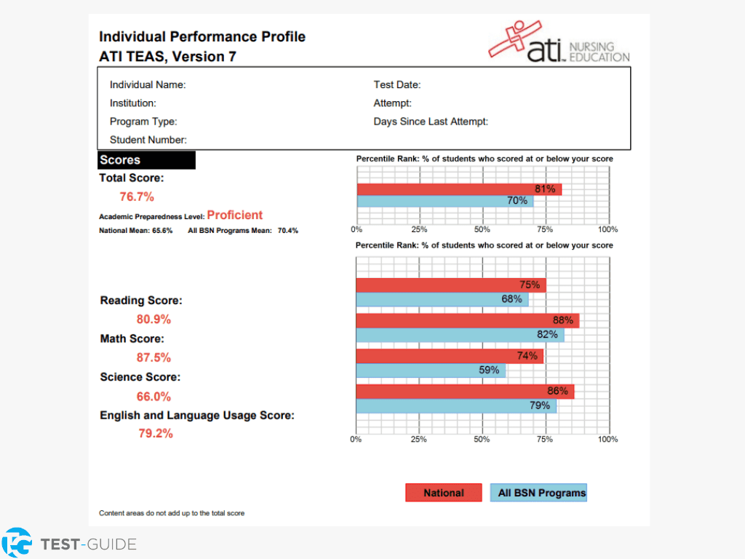
DOCUMENT EXAMPLE

Fall 2026 RADT Admission Selection Criteria (continued)

- Points will be awarded to residents of Idaho’s five northern counties (Benewah, Bonner, Boundary, Kootenai and Shoshone). Residency status will be determined by the Cardinal Central Office based on information submitted on the application.

- Points will be awarded to applicants who have completed a Bachelor’s degree or higher from an accredited U.S. Department of Education institution that is recognized by NIC. Official transcripts reflecting the degree detail must be received by the application deadline.

- Points may be awarded for health care certification/licensure. Documentation must include current state or federally approved credentials and must be provided with program application materials by the application deadline to be considered.

- Points may be awarded for radiology and imaging-specific health care work experience. Documentation for work experience should include a letter from the employer on company letterhead indicating the applicant’s name, normal (day-to-day) job duties affiliated with the position held, employment dates, and supervisor contact (phone and email) information. The letter must be signed and dated by the applicant’s supervisor and must be provided with program application materials by the application deadline to be considered.

- Additional Information:
- If necessary, GPA for program eligibility will be calculated on courses that meet degree requirements for the Radiography Technology Program.
- In the event there are applicants with an equal number of points, and the number of tied applicants outnumber the remaining open positions in the program, the following system will be used to determine who is selected:
    - Applicants with an equal number of points (tied) who have provided appropriate documentation of military service will be put at the top of their point category.
If there continues to be a tie, then:
    - GPA, as defined above, will be used to rank the remaining tied applicants.
If there still continues to be a tie, then:
3. A random drawing of all the remaining tied applicants will be held for the final seat

Prerequisite Course Information Sheet

Applicants completing prerequisite courses at a school other than NIC during the spring term prior to the program start date must complete and submit this prerequisite course information sheet along with required enrollment documentation.

The completed document and documentation of enrollment in the prerequisites listed below must be submitted with the application in order to provide evidence of program eligibility.

Student name:

Prerequisite course/s I am currently enrolled in or will be enrolled in during the spring term:

Name of college:

Course/s will be completed on (date):

Evidence of registration for prerequisite courses and this form must be submitted to Cardinal Central on or before the application deadline to be considered for application eligibility.

An official transcript with final grade details for all courses listed on form must also be received in the Cardinal Central Office by the application deadline to be considered for program eligibility.

Submit this page if applicable.

